Technical Appendix

## Catch the Pink Flamingo Analysis

*Coursera Big Data Specialization Capstone Final Assignment*

# Data Exploration

## Data Set Overview

The table below lists each of the files available for analysis with a short description of what is found in each one.

|  |  |  |
| --- | --- | --- |
| **File Name** | **Description** | **Fields** |
| ad-clicks.csv | Database of clicks on ads | timestamp: when the click occurred.  txId: a unique id (within ad-clicks.log) for the click  userSessionid: the id of the user session for the user who made the click  teamid: the current team id of the user who made the click  userid: the user id of the user who made the click  adId: the id of the ad clicked on  adCategory: the category/type of ad clicked on |
| buy-clicks.csv | Database of purchases. | timestamp: when the purchase was made.  txId: a unique id (within buy-clicks.log) |

|  |  |  |
| --- | --- | --- |
|  |  | for the purchase  userSessionId: the id of the user session for the user who made the purchase  team: the current team id of the user who made the purchase  userId: the user id of the user who made the purchase  buyId: the id of the item purchased price: the price of the item purchased |
| game-clicks.csv | A record of each click a user performed during the game. | timestamp: when the click occurred. clickId: a unique id for the click.  userId: the id of the user performing the click.  userSessionId: the id of the session of the user when the click is performed.  isHit: denotes if the click was on a flamingo (value is 1) or missed the flamingo (value is 0)  teamId: the id of the team of the user  teamLevel: the current level of the team of the user |
| level-events.csv | A record of each level event for a team. Level events are recorded when a team ends or begins a new level | timestamp: when the event occurred. eventId: a unique id for the event |

|  |  |  |
| --- | --- | --- |
|  |  | teamId: the id of the team  teamLevel: the level started or completed  eventType: the type of event, either start or end |
| team-assignments.csv | A record of each time a user joins a team. | timestamp: when the user joined the team.  team: the id of the team userId: the id of the user  assignmentId: a unique id for this assignment |
| team.csv | A record of each team in the game. | teamId: the id of the team name: the name of the team  teamCreationTime: the timestamp when the team was created  teamEndTime: the timestamp when the last member left the team  strength: a measure of team strength, roughly corresponding to the success of a team  currentLevel: the current level of the team |
| user-session.csv | A record of each session a user plays. | timestamp: a timestamp denoting |

|  |  |  |
| --- | --- | --- |
|  | When a team levels up, each current user session ends and a new session begins with the new level. | when the event occurred.  userSessionId: a unique id for the session.  userId: the current user's ID. teamId: the current user's team.  assignmentId: the team assignment id for the user to the team.  sessionType: whether the event is the start or end of a session.  teamLevel: the level of the team during this session.  platformType: the type of platform of the user during this session. |
| users.csv | Database of the game users | timestamp: when user first played the game.  userId: the user id assigned to the user. nick: the nickname chosen by the user. twitter: the twitter handle of the user. dob: the date of birth of the user.  country: the two-letter country code where the user lives. |

**Aggregation**

|  |  |
| --- | --- |
| Amount spent buying items | $ 21407 |
| Number of unique items available to be purchased | 6 |

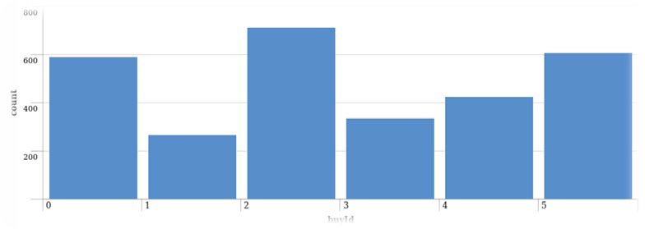A histogram showing how many times each item is purchased:

A histogram showing how much money was made from each item:

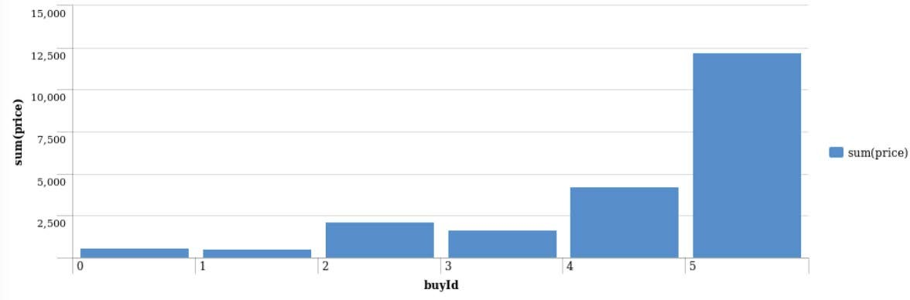

*Filtering*

A histogram showing total amount of money spent by the top ten users (ranked by how much money they spent).

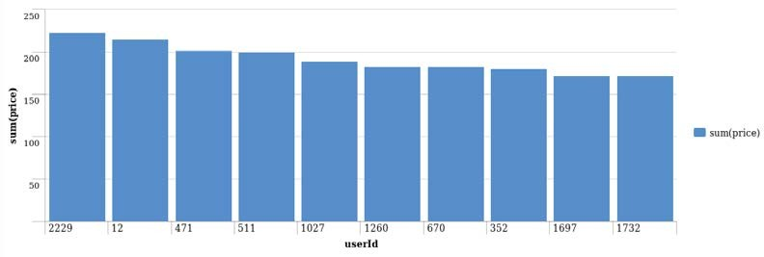

The following table shows the user id, platform, and hit-ratio percentage for the top three buying users:

|  |  |  |  |
| --- | --- | --- | --- |
| **Rank** | **User Id** | **Platform** | **Hit-Ratio (%)** |
| 1 | 2229 | iPhone | 11.5% |
| 2 | 12 | iPhone | 13% |
| 3 | 471 | iPhone | 14.5% |

# Data Classification Analysis

## Data Preparation

Analysis of combined_data.csv

**Sample Selection**

|  |  |
| --- | --- |
| **Item** | **Amount** |
| # of Samples | 4619 |
| # of Samples with Purchases | 1411 |

**Attribute Creation**

A new categorical attribute was created to enable analysis of players as broken into 2 categories (**HighRollers** and **PennyPinchers**). A screenshot of the attribute follows:

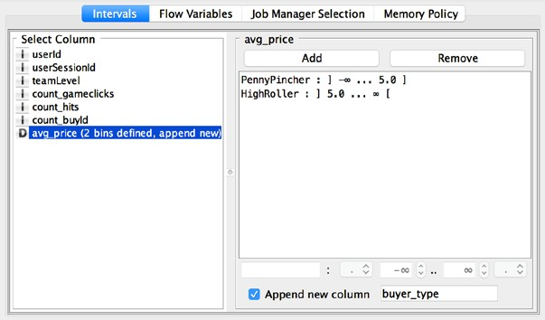

**Describe the design of your attribute in 1-3 sentences:**

High rollers are defined as those who purchase items over $5.00. Defining a new column based on the avg_price allows us to classify users accordingly.

The creation of this new categorical attribute was necessary because **our goal is to understand the attributes of who makes large purchases. This categorical variable is what we are going to base our decision tree upon.**

## Attribute Selection

The following attributes were filtered from the dataset for the following reasons:

|  |  |
| --- | --- |
| **Attribute** | **Rationale for Filtering** |
| userId | Not relevant for the model. |
| userSessionId | Not relevant for model. |
| avg_price | This feature was used to create the categorical feature “buyer_type”, the variable we are trying to predict based on other elements. We do not want to include this in our model. |

**Data Partitioning and Modeling**

The data was partitioned into train and test datasets.

The **training** data set was used to create the decision tree model. The trained model was then applied to the **test** dataset.

This is important because **partitioning the data set into training and test data allows us to verify the accuracy of the trained model.**

When partitioning the data using sampling, it is important to set the random seed because **it allows you to obtain reproducible results each time you run the partition.**

A screenshot of the resulting decision tree can be seen below:

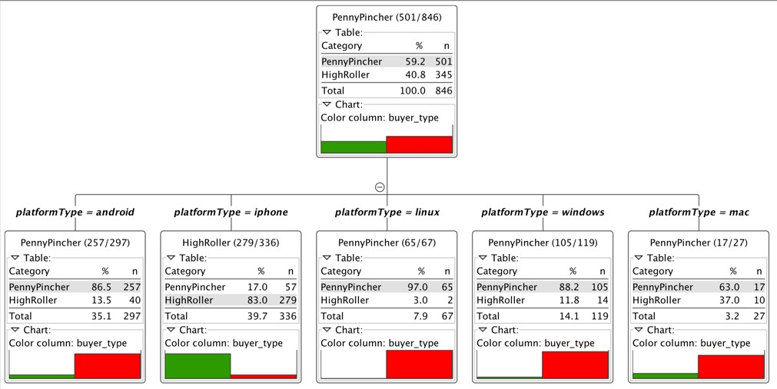

**Cluster Analysis**

**Attribute Selection**

|  |  |
| --- | --- |
| **Attribute** | **Rationale for Selection** |
| totalAdClicks | Total of ad-clicks per user. This attribute is correlated to the profit’s company. |
| totalBuyClicks | Total money of in-app purchase per user. This attributes is correlated to the profit’s company. |
| totalRevenue | Total money spent on in-app purchase items per user. |

**Training Data Set Creation**

The training data set used for this analysis is shown below (first 5 lines):

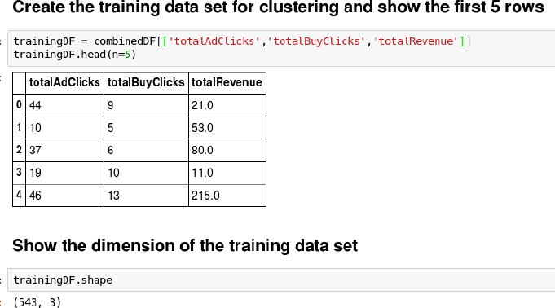

Dimensions of the training data set (rows x columns): **543 rows x 3 columns**

# of clusters created: **3**

**Cluster Centers**

|  |  |
| --- | --- |
| **Cluster #** | **Cluster Center** |
| 1 | [41.07, 10.29, 145.51] |
| 2 | [34.28, 6.45, 67.22] |
| 3 | [26.30, 4.48, 17.07] |

These clusters can be differentiated from each other as follows:

Cluster 1 is different from the others in that **the players in the cluster have the highest ‘totalAdClics’, ‘totalBuyClicks’ and ‘totalRevenue’.**

Cluster 2 is different from the others in that **the players in the cluster have the second highest ‘totalAdClics’, ‘totalBuyClicks’ and ‘totalRevenue’.**

Cluster 3 is different from the others in that **the players in the cluster have the lowest ‘totalAdClics’, ‘totalBuyClicks’ and ‘totalRevenue’.**

## Recommended Actions

|  |  |
| --- | --- |
| **Action Recommended** | **Rationale for the action** |
| Increase the prices for advertisements showed to players into first cluster | Players into the first cluster are frequent ad-clickers and increase the price of their ad, could increase the company’s revenue. |
| Charge players into third cluster lower fees for the price of the in-app purchase items | Players into the third cluster only purchase items with lower prices. Lowering the price of the in-app purchase or giving them coupons could encourage them to spend more. |

**Graph Analytics**

**Modeling Chat Data using a Graph Data Model**

The graph model is a network based on chat interactions between users. A chat session can be initiated by a user, other users on the same team are able to join and leave the session.

Interactions between users begins when a user create a post. It’s possible for a user, mention another user. All relationship between entities are logged with a timestamp.

**Creation of the Graph Database for Chats**

Describe the steps you took for creating the graph database.

### Write the schema of the 6 CSV files

|  |  |
| --- | --- |
| **chat_create_team_chat.csv** | userID teamID  teamChatSessionID timestamp |
| **chat_join_team_chat.csv** | userID teamChatSessionID timestamp |

|  |  |
| --- | --- |
| **chat_leave_team_chat.csv** | userID teamChatSessionID timestamp |
| **chat_item_team_chat.csv** | userID teamChatSessionID chatItemID timestamp |
| **chat_mention_team_chat.csv** | chatItemID userID timestamp |
| **chat_respons_team_chat.csv** | chatItemID_1 chatItemID_2 timestamp |

**Explain the loading process and include a sample LOAD command**

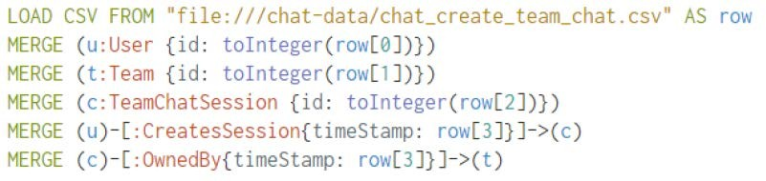

The first line load the csv from the specific location one row at a time. From the second line to fourth, create the nodes for User, Team, TeamChatSession with a specific column converted to integer, this field is used by the id attribute. The fifth and sixth lines create CreatesSession and OwnedBy edges and link the nodes previously created. The edges have a timestamp property filled by the fourth column of schema.

### Present a screenshot of some part of the graph you have generated. The graphs must include clearly visible examples of most node and edge types.

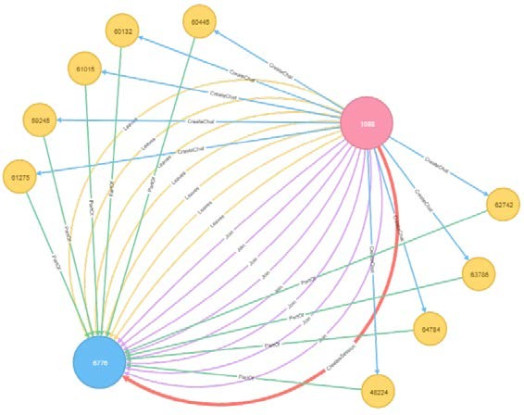

**Finding the longest conversation chain and its participants**

Report the results including the length of the conversation (path length) and how many unique users were part of the conversation chain. Describe your steps. Write the query that produces the correct answer.

### How many cats are involved in it?

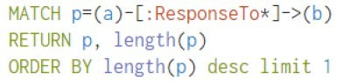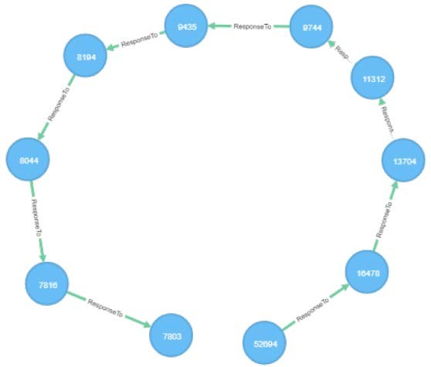

The longest conversation chain in the chat data has path length 9, therefore 10 chats are involved in it.

### How many users participated in this chain?

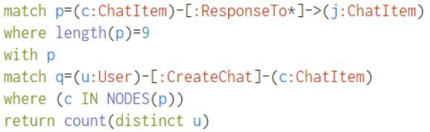

With 9 as longest path, count the number of distinct users who create ChatItem in this longest path. The query returns 5.

## Analyzing the relationship between top 10 chattiest users and top 10 chattiest teams

Describe your steps from Question 2. In the process, create the following two tables. You only need to include the top 3 for each table. Identify and report whether any of the chattiest users were part of any of the chattiest teams.

### Chattiest Users

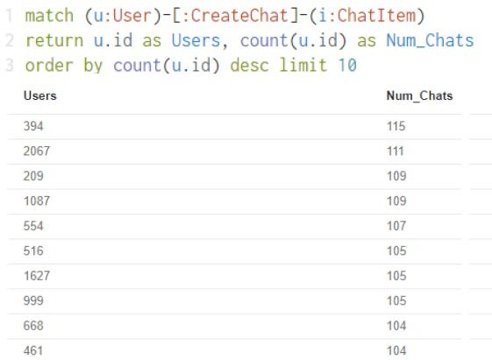Determine the number of chats created by a user from the CreateChat edge

|  |  |
| --- | --- |
| **Users** | **Number of Chats** |
| 394 | 115 |
| 2067 | 111 |
| 209 | 109 |

### Chattiest Teams

Match all ChatItem with a PartOd edge and connect them with a TeamChatSession node that have an OwnedBy edge connection them with any other node.

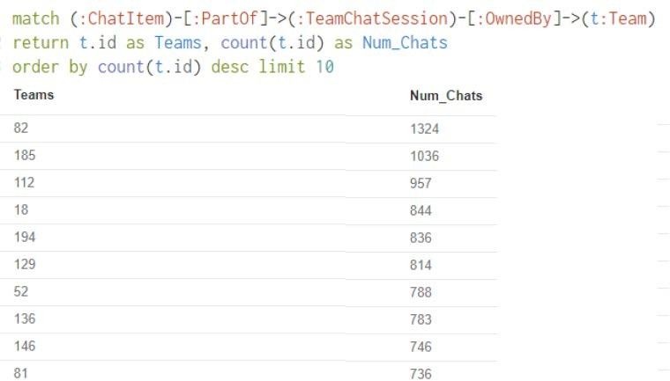

|  |  |
| --- | --- |
| **Teams** | **Number of Chats** |
| 82 | 1324 |
| 185 | 1036 |
| 112 | 957 |

Finally, present your answer, i.e. whether or not any of the chattiest users are part of any of the chattiest teams.

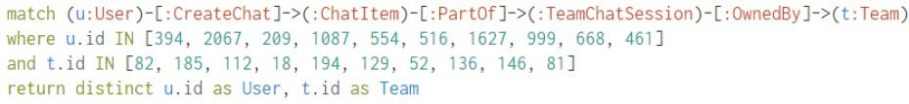

This query is used to investigate if the most chattiest user are part of any chattiest team and it return one result, userID 999 is part of teamID 52.

**How Active Are Groups of Users?**

Describe your steps for performing this analysis. Be as clear, concise, and as brief as possible. Finally, report the top 3 most active users in the table below.

### Connect mentioned users

**Connect users responses with the chat creator**

**Eliminate all self interaction**

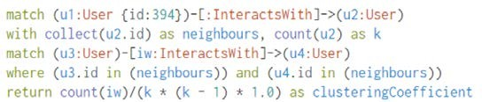**Calclulate the cluster coefficient.**

**Most Active Users (based on Cluster Coefficients)**

|  |  |
| --- | --- |
| **User ID** | **Coefficient** |
| 394 | 0.9167 |
| 2067 | 0.7679 |
| 209 | 0.9524 |